Job name: Re Install Expansion joint Unit 1
Description:
- Re Install ID Fan A Outlet Expansion joint

Picture  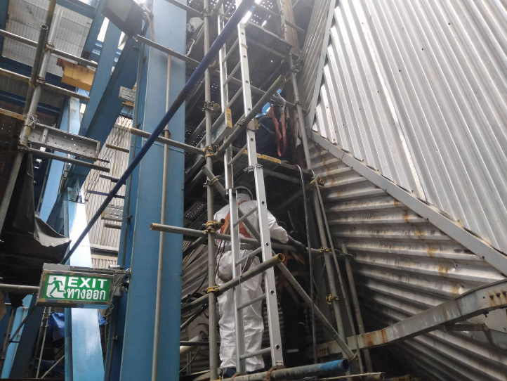 | 
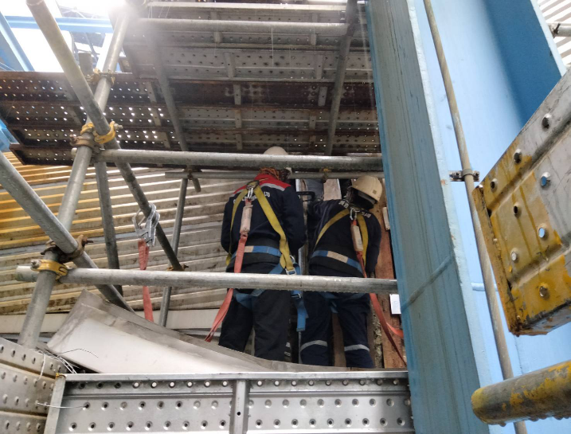 | 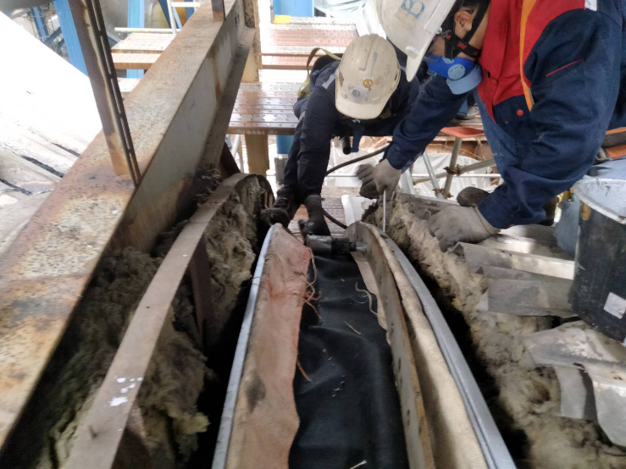
Remark:
Date: 06/08/2023

